**P3MD LAB - PROBE STATION INSTRUCTIONS v1.0**

The semi-automatic probe station, Cascade Summit 12000 series, is located in the P3MD Lab in Physics-360. This document describes the various parts of Probe Station, and describes instructions on using the Probe station. Please follow the instructions below in order for using the Probe Station.

1. **Entering the soft-wall clean room with proper attire**

Entering the clean room without proper attire is strictly prohibited. Figure 1 shows cap, face mask, lab coat, gloves and shoe cover which needs to be worn before entering cleanroom. Also, wearing anti-static devices and testing them before entering clean room is also recommended. Always make sure that you are in proper attire before you enter clean room.

C:\Users\mayur\Desktop\Physics work\SINTEF 2012 wafer map\Probe_station_instructions\DSCN0067.TIF

**Figure 1: Proper attire for clean room**

1. **Observe the probe station hardware**

Figure 2 shows the major components of Probe Station unit. The unit consists of:

* 1. The Cascade Summit probe station
  2. Keithley instruments (237 Source meter, K6485 Ammeters)
  3. LCR meter (for CV measurements)
  4. Switching matrix
  5. Temptronic chiller
  6. Cables
  7. Vacumm holder (Linicon)
  8. A-Zoom focus and light switch

Probe Station will be used for measuring IV and CV of the different pad positions on the wafer. K6485 are Picoammeters or Picometers used for measuring currents from pads on the wafer. Keithley 237 Source meter is used to supply bias to the wafer using chuck bias. LCR meter is used for low frequency as well as high frequency CV measurements (limit is -500V). The switching matrix is used to switch between IV and CV measurements directly, without changing the setup. Temptronic thermal system is used to maintain the wafer at a given temperature.

Figure 2 shows the various instruments used for focusing and holding the wafer. A-Zoom box provides the light for viewing the wafer during setup and needs to be switched off manually when the measurements are made. A-Zoom also provides focusing using 2 meter dials as shown in Figure 2. Figure 2 also shows the joystick which can be used for moving the focus to various positions on the wafer. The vacuum wafer holder is also shown in Figure 2. The vacuum holder only works when the switch on side is pressed on, leaving the switch turns off the vacuum and wafer will fall down. **SO, PLEASE MAKE SURE TO KEEP PRESSING THE SWITCH ON WHILE USING THE VACUUM HOLDER.**



**Figure 2: Light switch, Vacuum wafer holder, Joystick and focusing dial**

**IF YOU SEE ANY INSTRUMENT NOT WORKING OR ANYTHING UNUSUAL, PLEASE INFORM A SENIOR IN THE LAB IMMEDIATELY!!!**

Figure 3 shows the focusing dials of A-ZOOM in more detail. There are 2 knobs for coarse and fine grained control. There is also a light switch for switching the light inside the chamber. Also, notice the different zoom levels on dial (10, 20, etc.). The zoom level will be important when the probe positions are defined later.

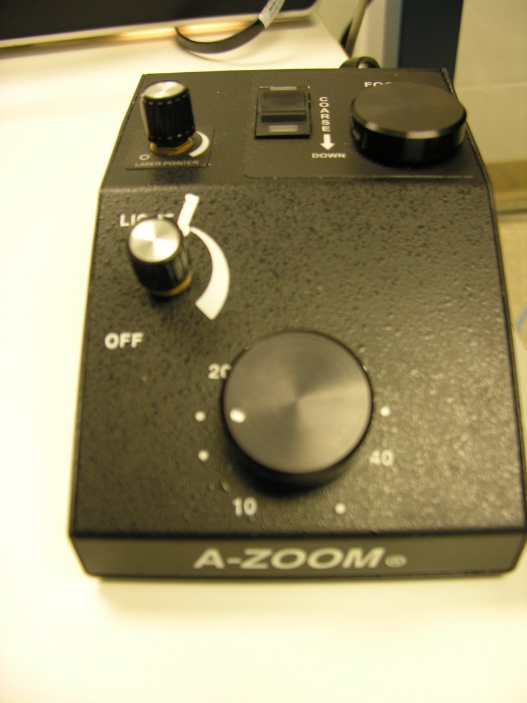

**Zoom levels dial**

**Fine control dial**

Figure 3 also shows the 4 probe needles. There are controls for moving the probe needles left-right, up-down and most importantly, lower-higher. The left-right and up-down knobs move the probe needle in XY plane. The lower-higher (in Z direction) moves the probe needles towards or away from the wafer. When the needles are away from wafer, they appear as 2 needles, while when the needles are close to wafer, they appear as single needles. **All the needle control knobs are very sensitive and should be used slowly and carefully.**



**Figure 3: Probe needles and Zoom controls**

1. **Probes and cabling**

The output of K237 provides the bias to the chuck which goes to the probe station. Also, the outputs from probes are connected to Pins 1 and 2 on the top of the probestation. These outputs are connected by BNC connectors to the Keithley 6485 picometers. All the COM terminals of 6485and 237 are connected together to form a common ground. Also, all units are connected to a PC using GPIB cables. These different GPIB cables are daisy chained together and all the bias voltages and current measurements can be displayed and recorded on the computer using GPIB connections. LabView code is used to measure both IV and CV data and automatically apply bias using the display panel on the computer.

The IV measurement is done first over all pad positions defined in the wafer map. After the IV measurement is done, CV measurements are taken. The LCR meter must be manually connected as in Figures 4 and 5. Output Hi and Output Lo pins of K237 are connected to red and black input pins at the back of the LCR meter as shown in Figure 5. Also, the RED pins at the front of the LCR meter are connected to the Chuck bias at the back of the probe chamber (similar to how the K237 was connected for the IV test). Also, the black pin at the front of the LCR meter receives the measured capacitance value from the probe needle and is connected back to the LCR meter via Pin 1.



**Figure 4: Outputs from LCR meter to bias and Probe Station to LCR meter**



**Figure 5: Outputs from K237 and LCR meter to Probe Station**

**NOW YOU ARE READY TO SETUP THE SOFTWARE!!!**

1. **Run “Nucleus” on PC’s desktop**

Open Nucleus by double-clicking the Nucleus icon on the desktop. The login credentials are: login name: Superuser, Password: cascade. The main windows that open are:Nucleus main panel, Live Video and Motion Control.

* 1. First click the button “Wafer Load” in the motion control sub-window. The Live Video window will show the focus position moving from the center of the chuck to the top edge of the chuck. Also, a message will be displayed saying that Wafer access interlock is open.
  2. Next open the probe station micro-chamber door. The chuck and chuck interlock should be visible as shown in Figure 6. Unlatch the chuck interlock and pull out the chuck. Pull the chuck all the way back until you feel a click. The chuck should now be held in place and not go back after you let go of the latch.
  3. Check to make sure that the “Turn Vacuum Off” button is set on the Nucleus window. Otherwise, the vacuum will be ON before you place the wafer down.
  4. Check to make sure the chuck surface and conductive rubber are both clean. If the surfaces are dirty, clean them using IPA solution.

 

**Figure 6: Chuck and loading surface**

1. **Wafer loading**
   1. Check if lever arm is down. If not, lower the lever arm
   2. Make sure the vacuum pump is turned on
   3. Take a wafer from the dry box cabinet in the soft-wall clean room. Use the vacuum holder to lift the wafer from the wafer box. Use tweezer or spatula like pinchers to hold the end of wafer while vacuum holder is still on. Be very careful when handling the wafer. **IMPORTANT: Make sure that the vacuum holder black button is always PRESEED ON when the wafer is held; else the wafer will fall on ground**.
   4. Put the wafer slowly in the center of the conductive rubber. Once the wafer is placed on the chuck, release the vacuum button to leave the wafer on the chuck. **IMPORTANT: Once the wafer is released from the vacuum pen it may slide around on the rubber.**
   5. Check if the wafer is placed in the center of the chuck and make sure that all the vacuum holes on the conductive rubber are covered. Else, move the wafer slowly to make it at the center. Make sure you always handle wafer along the flat edge. Also, the flat edge must be facing you when you place it.
   6. Turn the “Vacuum On” in main panel. Check with the tweezer or vacuum pen that the wafer is stuck to chuck and does not move.
   7. Mechanical alignment. This step is done to align the wafer as much as possible using an eyeball estimate. To do this, using the latch push the wafer towards micro-chamber so that edge of micro-chamber door is parallel to any of the major lines on the wafer. If not, turn off the vacuum and very slowly move the wafer to align it to edge of the chamber. Try to align it as much as possible. Fine alignment of the wafer will be done using software.
   8. Turn the Vacuum back on in the Nucleus window
   9. Push the chuck back into the probe station chamber and lock the latch
   10. Close the micro-chamber gate
   11. Turn the light ON by flipping the A-Zoom power switch
   12. In Nucleus click “Wafer Center” in the motion control window.
2. **Wafer Alignment**
   1. Zoom in (<30) and adjust the focus
   2. Click on the tools tab in the Nucleus window and select “Align” and make sure the following options are set
      1. Start at center: OFF
      2. Scan Velocity: Fast
      3. Scan Method: Wait at end
      4. Scan Distance: Define with Joystick
   3. Click “Start Align”. The Align procedure scans back and forth between two fixed points, stopping at each end point and asking if the alignment should continue
      1. Select the LEFT end point
      2. Select the RIGHT end point
      3. When selecting end points make sure they both lie along the same visible line on the wafer. Pick a horizontal that is as long as possible.
   4. Click “Continue” and the procedure will travel from one end point to the other. You should notice that after it reaches the 2nd endpoint it will have deviated by some angle from the wafer line
   5. At the 2nd endpoint note the deviation from the wafer line and adjust the theta knob until the crosshair is half the deviated angle from the wafer line. Then click continue.
   6. The Alignment procedure should move back to the 1st endpoint. Once there move the crosshair back to the wafer line that you are using for alignment and then hit continue. NOTE: Do NOT adjust the theta knob at the 1st endpoint to align the crosshair, only move using the Nucleus controls to adjust the crosshair position.
   7. Repeat steps e-f until the crosshair stays parallel with the wafer line, That is there is no visible deviation as the crosshair travels from one endpoint to the other.
   8. Click “No” when it asks to Continue and then “Close”. The Wafer should now be officially aligned
3. **Setting Up The Wafer Map**
   1. First move the crosshair to Site 1 on the wafer. For the 6in Wafers this is the diode in the lower left corner as shown in Figure 7
   2. Align the crosshair over the top left contact pad. Make sure that the probe tips can reach their respective pads.
   3. Right click on the Live Video window and select “Set Reference in Place”
   4. If not already open, open the Wafer map window from the Nucleus window
   5. Make sure that the correct wafer map is loaded, to check this simply look at the top of the Wafer Map window and note the name of the Wafer map. For the 6-inch wafers the correct wafer map is “2013\_6-inch\_wafer\_map1.wfd”
   6. Click on the “Sub Die” button in the Wafer Map window. This will open another window that shows the relative positions of all the sites with respect to site 1. If the reference position was correctly set to Site 1, double clicking on any of the other Site numbers in the Sub Die window will move the probes to that Site. If after selecting another site the probes do not move to the correct location, either the wrong wafer map is loaded or the reference position was not set correctly.

NOTE: In Nucleus the Site numbers are counted starting from 0, so Site 1 in Nucleus is Label 0; Site 21 is Label 20 in Nucleus and so on.

Figure 7: Site Layout for 6-inch Wafer

1. **Probe Tip Setup**

We are now ready to start the IV/CV scan. Make sure the Kiethleys are connected properly to the probe tips and chuck.

* 1. Make sure ALL of the probes are a safe Z-distance above the wafer, then click on “Move the Z stage to contact” the symbol should turn green, indicating that the probestation is in contact mode. While in this mode you cannot move the chuck using the Nucleus software.
  2. Move the probes above their respective pads, the probe tip that comes in at an angle is usually used for the Active area and the other probe tip is used for the Guardring.

NOTE: Make sure that the wires connecting the probe tips to the K6485s are correctly labeled, the K6485 with GPIB address 10 is used for measuring the Guardring and the K6485 with GPIB address 14 is used for measuring the active area.

* 1. Using the knobs on the probestation lower the probe tips into contact with the pads. If the K6485s are in local mode you should hear a set of clicks when the probe tips first make contact with the pads and the K6485s should also be reading small current value.
  2. Turn the light off

1. **IV/CV Measurment**
   1. Open “Automatic\_IV\_CV\_with\_XML\_Global\_Stop\_V1.1” VI
   2. On the front panel set values for voltage ranges and voltage step size for both IV and CV. Also, make sure the Site number is set to the appropriate values for IV and CV (For the 6-inch wafer there should be 22 sites for the IV scan and 12 for the CV scan). Finally make sure the file path is set to an appropriate location as this is where the data will be saved to.
   3. Run the program
   4. You will be prompted to fill out various fields that are used to document the data
      1. Wafer ID#: The ID# of the wafer currently being tested
      2. Name of Test: This will create a folder with the specified name and will be the location for all the data collected for that particular run. If a folder with the name already exists, then a 2nd folder will be created with an appended number. This ensures that each folder contains only one set of data
      3. Comment Description(optional): A field used in the XML output
      4. User(optional): A field used in the XML output
   5. Next a prompt to Skip Subsite will appear, if for whatever reason you do not wish to collect data on this site click “Skip”, otherwise click “Continue”
   6. At this point the Labview code makes a check to see if the probe tips are in contact, if they are not an error window will appear indicating that the probes did not go into contact with the pads.
      1. Check to make sure that the K237 is in Standby mode if it isn’t attempt to manually set it to standby mode
      2. Turn on the light

NOTE: If the K237 is not in Standby mode when the light is switched on you WILL arc the sensor and possibly ruin the entire wafer. So make sure that the light is only turned on when the K237 is in standby

* + 1. Check to see if the probes are still aligned with their respective pads. If they are very gently lower the probe tips until they are in contact with the pads.
    2. Another possibility for the contact check is that the probestation did not go back into contact mode after moving to the Site. To check this look at the status of the Stage height in the Motion Control window. If it is set to “Separate”, check to make sure the probes are aligned above their respective pads and then click “Move Stage to Contact”.
    3. VERY IMPORTANT: Turn the light off
    4. Retry the contact check, if the error occurs again repeat steps i-v or choose to skip the current Site

NOTE: If the contact check failed due to the Stage being stuck in Separate mode, the Stage will remain in Separate mode for the remainder of the scan unless you move it back to Contact mode. Make sure you only do this during the contact check error window and make sure that the probes are in the correct positions before changing the Stage mode.

* 1. If the contact check passes the Labview code will begin the IV scan and data should begin to appear on the graphs in the Front Panel.
  2. After the scan completes for the current site the code will move to the next site, so repeat steps e-g
  3. After all the sites have been scanned a new window will appear indicating that the IV scan is complete. At this point switch the wiring setup to CV. Only after you are sure that the wiring is correct should you hit continue
  4. A similar window asking if you would like to skip the current subsite will appear during the CV scan. Click “Skip” if you do not wish to take data for the current site or “Continue” if you do.

1. **Shutting Down**
   1. Make sure that all the instruments are in Standby and sourcing no voltage
   2. Turn the light ON
   3. Manually raise the probe tips using the knobs on the probestation
   4. Click “Move the Z Stage to separate” button in the Motion Control window
   5. Click “Wafer Load” button the Nucleus Motion Control window. This will bring the chuck forward so that it can be pulled out and accessed easily.
   6. Open the micro-chamber gate. Pull out the chuck and secure it in place
   7. Click “Turn Vacuum OFF” symbol on the Nucleus window
   8. Use the Vacuum Pen and spatula to very carefully remove the Wafer from the conductive rubber. This step can take a very long time and it is very important that the Wafer is removed carefully as the rubber will have adhered to the wafer making peeling the wafer off of the rubber very tricky.
   9. Place the Wafer back in its case. Make sure that you place it in the correct side of the wafer container.
   10. Place the wafer container back in the dry box
   11. Close the micro-chamber gate
   12. Turn the light OFF

This Concludes the tutorial for operating the probestation for an Automatic IV/CV scan